**ASSIGNMENT - 16.4**

**Problem Statement:**

In many countries, the public telephone network has a single emergency telephone number (sometimes known as the universal emergency telephone number or the emergency services number) that allows a caller to contact local emergency services for assistance. This emergency number differs from country to country and typically consists of three digits numbers that can be easily remembered and dialed quickly. Some countries have a different emergency number for each of the different emergency services.

Write a mapreduce program use map side join to join the two datasets and find What kind of problems are prevalent, and in which state? Here we have two data sets; one is the data that the callers has given when they called the emergency helpline number.

**Input:**

You can download the 911 data from the below link. <https://drive.google.com/open?id=0ByJLBTmJojjzNjI5ZWdYa2FYbGs>You can download the zipcodes data from the below link. <https://drive.google.com/open?id=0ByJLBTmJojjzemowRE9oMUphY2M>

The data set description for the 911 data is as follows: lat: String variable, Latitude lng: String variable, Longitude desc: String variable, Description of the Emergency Call zip: String variable, Zip code title: String variable, Title timeStamp: String variable, YYYY-MM-DD HH:MM:SS twp: String variable, Township addr: String variable, Address e: String variable, Dummy variable (always 1) .

The data set description for the zip code file is as follows: zip: String variable, Zip code city: String variable, City state: String variable, State latitude: String variable, Latitude longitude: String variable, Longitude timezone: String variable, Time zone dst: String variable, district.

**Program:**

**Driver Class:**

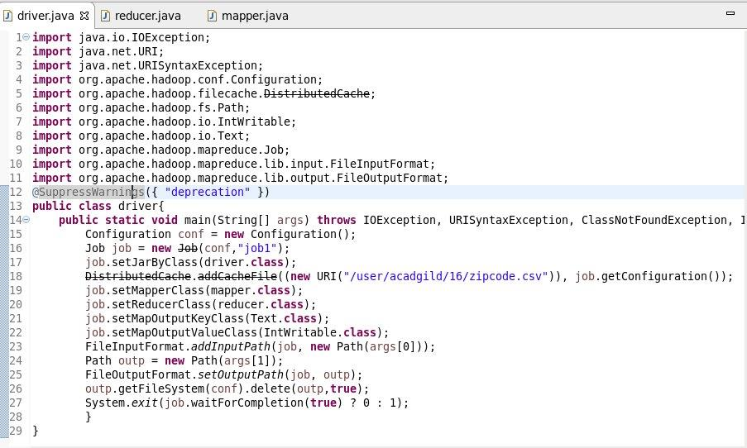

**Mapper Class:**

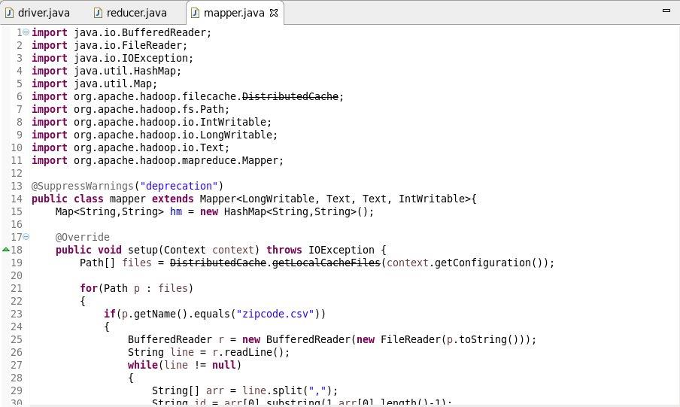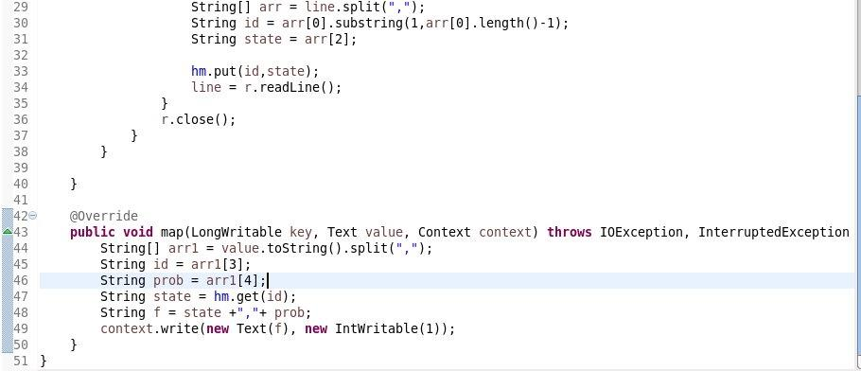

**Reducer Class:**

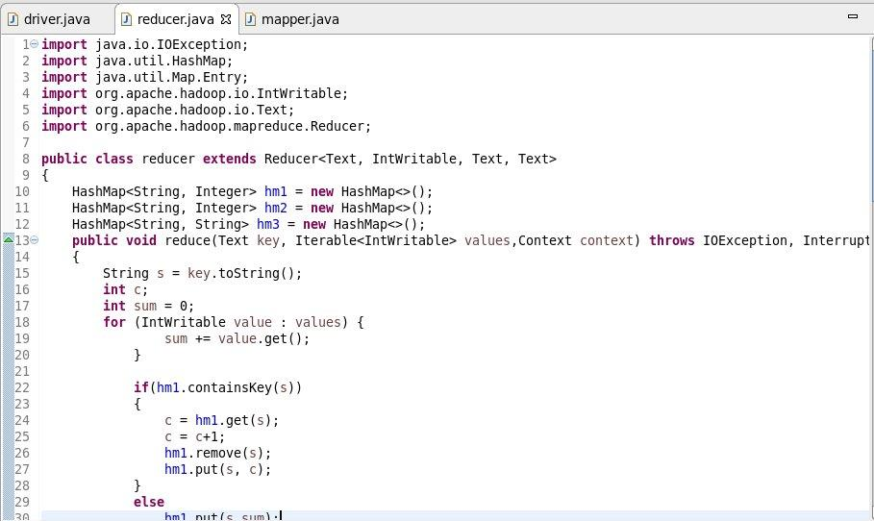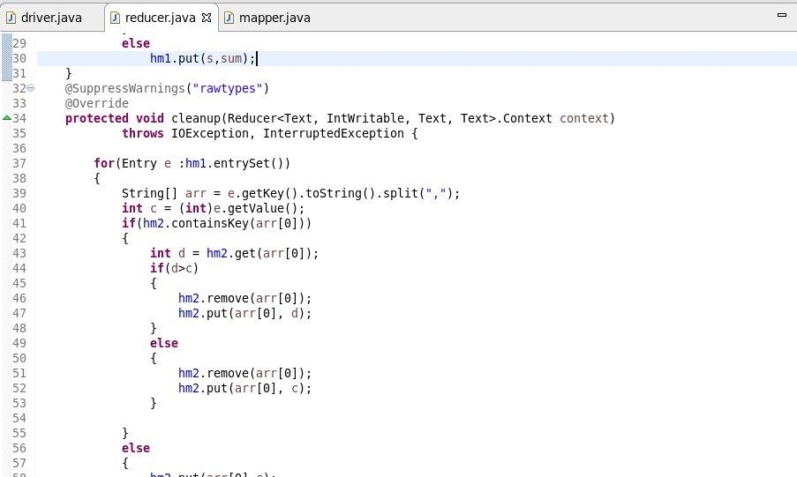

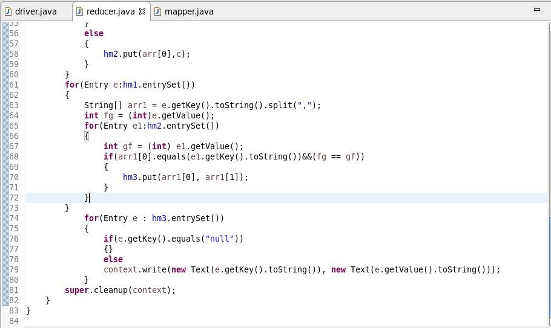

**Output:**

